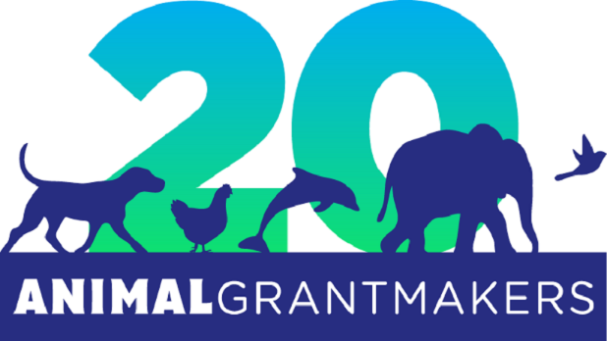

Animal Grantmakers to Join Kirkpatrick Foundation in Hosting Animal Funder Luncheon in Oklahoma City January 22, 2020

Oklahoma City – January #, 2020 – Animal Grantmakers, the only funder affinity group focused solely on animal protection, has been invited by the Kirkpatrick Foundation, a private foundation in Oklahoma City, to co-host a complimentary luncheon for animal funders from Oklahoma and around the United States on January 22, 2020 at Oklahoma City Golf and Country Club. The announcement came today from Louisa McCune, who is both incoming board president of Animal Grantmakers and executive director of the Kirkpatrick Foundation, an Animal Grantmakers member organization.

“The Kirkpatrick Foundation’s vision is to make Oklahoma the safest and most humane place to be an animal by the year 2032,” said McCune. “This cannot be achieved in a vacuum. By participating in philanthropy serving organizations like Animal Grantmakers, funders of animal protection programs can learn from one another, hear about areas of critical need and new or expanded initiatives to address them, strategize about how to scale up the impact of effective programs that benefit animals, explore opportunities to collaborate and improve their grantcraft.”

The upcoming luncheon, which will start at 11 a.m. and conclude at 1 p.m., aims to bring together grantmakers with a shared concern for animals with the hope that attendees will expand their networks, increase awareness of the programs they support and plant the seeds for future collaborations. Guests will also have the chance to learn how participation in Animal Grantmakers can help further their organizations’ respective missions, as well as advance the field of animal protection philanthropy as a whole.

“Although animal protection funding has grown measurably since the formation of Animal Grantmakers 20 years ago, animals/environment is still the smallest category of giving to charitable organizations,” said McCune. “I look forward to seeing where our combined efforts take us over the next 2020 years, in Oklahoma, across the country and around the world. Let’s begin by joining us for lunch on January 22!”

To RSVP, animal funders can send an email to rsvp@kirkpatrickfoundation.com or call (405) 608-0934.

About Animal Grantmakers
Animal Grantmakers, a 501(c)(3) non-profit organization, is the only funder affinity group focused solely on animal protection. A diverse group of foundations, public charities, corporate giving programs, individuals and other philanthropists, its members work on local, regional, national and global issues involving animals of all types living in all types of environments. The mission of Animal Grantmakers is to support effective grantmaking, advance collaborative efforts, and expand the sphere of animal protection philanthropy to cast a wider and stronger safety net for animals in the communities its members serve, improving outcomes and elevating the field. To learn more, visit www.animalgrantmakers.org.

About Kirkpatrick Foundation
(insert Kirkpatrick boilerplate)

# # #

Media Contacts:

(insert Kirkpatrick PR contact)

Jill Hoffman
communications@animalgrantmakers.org
323-719-7111

