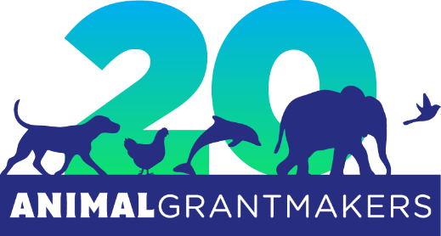

Animal Grantmakers to Hold 20th Annual Conference in Minneapolis, October 20 – 23, 2019

Convening Will Mark Funder Affinity Group’s 20th Anniversary

Los Angeles – August 30, 2019 – Animal Grantmakers, the only philanthropy serving organization focused solely on animal protection, will host the 2019 Animal Grantmakers Conference this fall in Minneapolis, MN from Sunday, October 20 to Wednesday, October 23. Held exclusively for foundations and organizations, as well as individuals, that make grants for the benefit of animals, this year’s educational and networking event will also commemorate the 501(c)(3) non-profit organization’s 20th anniversary.

Sponsored by Maddie’s Fund®, PetSmart Charities®, the ASPCA® (American Society for the Prevention of Cruelty to Animals®), Michelson Found Animals Foundation and others, the 2019 conference program will provide an unparalleled opportunity to hear from leading experts in the field of animal protection on many challenging issues, topics and trends relevant to funders.

Highlights of this year’s conference include: field trips to The Wildcat Sanctuary, The Raptor Center and Wildlife Rehabilitation Center of Minnesota, and Main Street Project (Model Chicken Farm); a welcome reception and 20th anniversary toast; a gala dinner and keynote presentation from Daniel Lebbin, vice president of threatened species at the American Bird Conservancy; and, a special field trip on the final day to Animal Humane Society (AHS) in Golden Valley, MN, where attendees will see AHS’s pioneering dog habitat prototype and learn how its Veterinary Center’s experts help the community with high-quality, low-cost veterinary services.

Other conference speakers will cover such topics as: advancing animal welfare in wildlife rehabilitation; animals caught between two worlds; the illegal pet trade, with a focus on African grey parrots; paradigm shifts in public animal control; Shelter Animals Count’s national database of sheltered animal statistics; diseases in wildlife rehabilitation centers and companion animal shelters; the power of alliances; maximizing support for grantees; bold philanthropy (case studies looking at calculated funding risks); Native American-led strategies supported by animal welfare allies; strategies for a more just and humane animal agriculture; compassion fatigue in veterinarians and animal rescue workers; and more.

“As every member receives two free registrations, the annual conference is a premium benefit of membership in Animal Grantmakers,” said Nikki Kelley, chair of the 2019 conference and data scientist at Best Friends Animal Society. “Of course, non-members are also welcome to attend for a fee, as long as they make animal protection grants.”

The deadline to register for the conference is October 1, 2019, and the last day to book a room at the historic Renaissance Minneapolis Hotel, The Depot at the Animal Grantmakers group discount rate is September 20, 2019.

“I look forward to this very special conference every year,” said Shelly Thompson, president of Animal Grantmakers and director of grants at Maddie’s Fund. “No other event allows me to connect with as many like-minded individuals, increase my knowledge of animal issues and learn from others in the field about grantmaking best practices.”

Representatives of non-member foundations that are interested in learning more about Animal Grantmakers are invited to attend their first conference at no charge. For more information about this opportunity, contact membership@animalgrantmakers.org.

About Animal Grantmakers
Animal Grantmakers, a 501(c)(3) non-profit organization, is the only funder affinity group focused solely on animal protection. A diverse group of foundations, public charities, corporate giving programs, individuals and other philanthropists, its members work on local, regional, national and global issues involving animals of all types living in all kinds of environments. The mission of Animal Grantmakers is to support effective grantmaking, advance collaborative efforts, and expand the sphere of animal protection philanthropy to cast a wider and stronger safety net for animals in the communities its members serve, improving outcomes and elevating the field. To learn more, visit www.animalgrantmakers.org.

# # #

Media Contact:
Jill Hoffman
communications@animalgrantmakers.org
323-719-7111

